Title of the work that will be presented on the International Conference
(Times New Roman, bold, font size 14, center)

N. Surname¹*, N. Surname², N. Surname³,..
(Times New Roman, bold, font size 12, center)

¹Authors' affiliation 1, Full affiliated institution address, city, country, e-mail
^{2,3}Authors' affiliation 2,3, Full affiliated institution address, city, country, e-mail
*Corresponding author (e-mail address): e-mail
Type of paper (Style: Type of paper)
Abstract (Times New Roman, bold, font size 11)
The Abstract should not exceed 300 words. The abstract should state the principal objectives of the research, the methodology used, the summarized results, and the main conclusions. The paper should be written in English, using Microsoft® Office Word 2003 or higher. The entire paper must not exceed 4 pages.
Keywords: a list of up to 5 key words (3 to 5) (Times New roman, italic, font size 11)

INTRODUCTION (Times New Roman, bold, font size 11)

The introduction begins one line below the title. Use Times New Roman, font size 12, single spacing, and justified alignment. The superior and inferior margins must be 25 mm, and the left and right margins must be 30 mm. All margins are 2.5 cm. Do not put number on the pages. For emphasizing a word or phrase, use italic. Do not use bold or capital letters. Bold or capital letters should be used only for section headings.

MATERIALS AND METHODS (Times New Roman, bold, font size 11)
This section should be written following the same writing style and formatting guidelines described in the previous chapter for the Introduction. Clearly describe the materials used and the procedures applied in this study.
References within the text should be cited in straight brackets according to the order of appearance. For example: Numerous authors have investigated the influence of ........ [1], [4,7].
All tables and figures must be numbered. Table titles should be written above the Tables, while Figure captions should be placed below the Figures.
Below are examples of how to cite Tables and Figures. Figures and tables must be cited in the text in consecutive numerical order as: Figure 1, Figure 2, etc.
Table 1. Caption of table
Sample 1 | Sample 2 | Sample 3 | Sample 4 | Sample 5
0.1 | 0.2 | 0.3 | 0.4 | 0.5

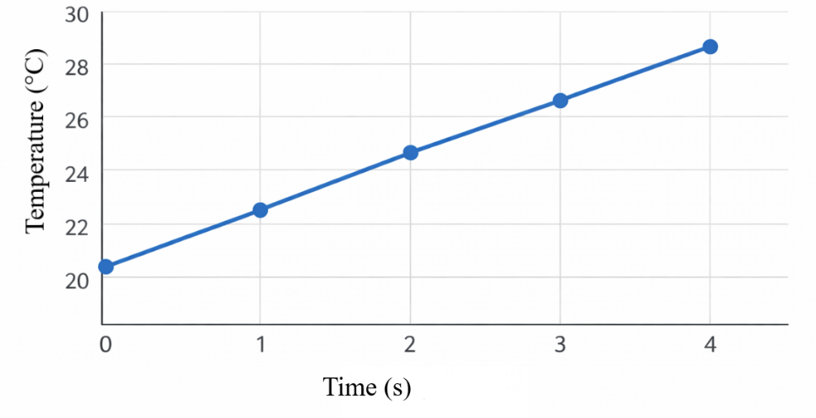
Figure 1. Graph of Time-Dependent Temperature Change

Equations must be written using the MS Word integrated MS Equation editor, centered, and numbered consecutively in rounded brackets.
$ax^{2}+bx+ c=0$ (1)

Variables, counting indexes and letters representing physical values should be written in the same font but in italics. The font Symbol in italics, or similar should be used for Greek letters.

RESULTS AND DISCUSSION (Times New Roman, bold, font size 11)

This section should be written following the same writing style and formatting guidelines as described in the previous chapters.
CONCLUSIONS (Times New Roman, bold, font size 11)

This section should be written following the same writing style and formatting guidelines as described in the previous chapters.
Acknowledgements (Times New Roman, bold, font size 11)
This work was supported by the ****.
REFERENCES (Times New Roman, bold, font size 11)
References are cited in the text using straight brackets and are listed at the end of the paper in the order in which they appear in the text. The literature at the end of the paper is formatted as follows:
  - A. Author, B. Author, C. Author, Title of the journal article, Journal Name, Volume(Year)Issue, pages from–to., doi:xxxx
  - A. Author, Title of the paper in conference proceedings, Title of the proceedings, (Editors: D. Author, E. Author), Publisher, Conference dates from–to, Year, City, Country, pages from–to.
  - A. Author, Title of the book, Publisher, City, Country, Year of publication.
  - A. Author, Title, Available online: link (access date).

